Facilit9ator note:

Master m to train CRPs

ट्रांसलेट मेरा नाम रमेश सोलंकी है में पेटलावद जनपद पंचायत का dअध्यक्ष हूं दीदिया पेटलावाद में लिंग सरहनिया करुबकर रह रहे हैं हमारे पेटलावद में जनपद स्टार पर l लिंग फोरम कंघाठन किया”
Mm

O

Contents
Introductiono1
Modules (Session Plan) of the Manual 2
Session 0 Registration of participants 5
Session1: Welcome and Lakhpati Didi training overview 7
Session 2: Concept of Lakhpati Didi 8
on 3: Lakhpati Livelihood opportunity 10
Session 4: Lakhpati Livelihood Planning 16
Session 5-Lakhpati planning process and tools 23
Handholding of Lakhpati Didi and role of stakeholders 27
Session 7: Resource provisions 32
Session 8 Aajeevika register 36
Recap of Day 38
Session9: Social Security Schemes 39
Session 10: Group exercise on lakhpati planning tool 44
Session 11: Orientation of VO/CLF on lakhpati 45
Session 12: Lakhpati household Livelihood planning 46
Session 13: Valedictory & feedback 48

Introduction
The DAY-NRLM has taken up Lakhpati initiative deepened through its four components i.e. entitlements, livelihoods, public goods, services and resources development, and social development plans. Recently, thrust has been given for universalization of livelihood outreach, among rural households. Accordingly, the lakhpati livelihood planning process has been revamped to prepare a well-rounded lakhpati plan for individual households. The plan is mainly driven by the Village Organization (VO).and assisted by CRPs. The current module is targeted to enable Cluster Level Federations to facilitate the livelihood planning process effectively. While designing the content for this manual, the role of CLF, the required knowledge and skills for the EC members of CLF has been considered.

Objective of the Manual
At the end of this training, Livelihood CRPs are expected to have enhanced knowledge and skills on:
What is livelihood, its types and need for household level livelihood planning, strengthening of livelihoods, need of diversification and resource envelope
Elements, rationale and process of livelihood profile (for household and village) preparation including use of planning tool
Elements, relevance and process of Lakhpati planning at SHG level using application
Conducting VO Concept Seeding training
Role, tasks and reporting structure and mechanisms
Facilitate and prepare profiles of SHG members and livelihood activities they are involved in.
Facilitate and prepare livelihood plans for SHG member using planning tool
Role of CRP in supporting VOs for livelihoods plan presentation, implementation and tracking

Target Users
This manual is designed for Lakhpati-CRPs of the Village Organization who will be engaged in facilitating the lakhpati livelihood plan and VO/CLF orientation on lakhpati livelihood. Further this can be translated to local language so that facilitators of the program can use it further to enhance understanding of CRPs on livelihood promotion in their project area through family-based planning.

Modules (Session Plan) of the Manual
Total number of Sessions: 13 Sessions
Time required: 10 hours 15 Minutes spread across 2 days
The manual contains the following substantive modules as briefly described below:
PROGRAMME SCHEDULE
Timings | Particulars | Link to the Presentation
Day-1
09.30AM-10.00AM | Registration of participants | Format link:  https://forms.gle/jK7GYmTSwvsD8N6AA  Ppt link: https://docs.google.com/presentation/d/1CEIbVjLj2ruilR7DNbVkQPWFGRZPa40d/edit?usp=sharing&ouid=111221402645274011756&rtpof=true&sd=true
10.00AM-10.30AM  Session-1 | Welcome of participants  Overview of Lakhpati Didi training | https://docs.google.com/presentation/d/13WJruiMAtw7pVoD3lvwzyuXBilGKst4E/edit?usp=sharing&ouid=111221402645274011756&rtpof=true&sd=true
10.30AM-11.00AM  Session-2 | Concept of lakhpati Didi | https://docs.google.com/presentation/d/19-qDA6TP0Hkfxm2d7vUa4YoyYxmScZpr/edit?usp=sharing&ouid=111221402645274011756&rtpof=true&sd=true
11.00AM-11.30AM  Session-3 | Lakhpati Didi Livelihood Opportunities | https://docs.google.com/presentation/d/1gg8TRmAStMZe4I4rbzvH2d5vNAEGljxo/edit?usp=sharing&ouid=111221402645274011756&rtpof=true&sd=true
11.30 AM-11.45AM | Tea break
11.45 AM-1.15PM  Session-4 | Lakhpati livelihood planning Components | https://docs.google.com/presentation/d/1VnP3okfv-dTCWYEHAVoO-7PnNUBdN--V/edit?usp=sharing&ouid=111221402645274011756&rtpof=true&sd=true
1.15PM-2.00PM | Lunch Break
2.00PM- 2.30PM  Session-5 | Livelihood Planning process & tool | https://docs.google.com/presentation/d/1-qBmqPAeUTFDcVDzB4Wvobme7GA8a-3o/edit?usp=sharing&ouid=111221402645274011756&rtpof=true&sd=true
2.30PM- 3.00PM  Session-6 | Handhold of lakhpati Didis and role of stakeholders | https://docs.google.com/presentation/d/12y6PJdTuKCTGVdmeZXCs_tF0d1-GZU0M/edit?usp=sharing&ouid=111221402645274011756&rtpof=true&sd=true
3.00PM-4.00PM  Session-7 | Resource Provisions | https://docs.google.com/presentation/d/1egjE5NCHDsltGh06Vo-RERN27QK2Iqei/edit?usp=sharing&ouid=111221402645274011756&rtpof=true&sd=true
4.00 PM- 4:15 PM | Tea break
04.15PM- 5:00 PM  Session-8 | Aajeevika Register | https://docs.google.com/presentation/d/1J4vfGXRSpFoHAgDJdJgLTAR1ieEGwHNq/edit?usp=sharing&ouid=111221402645274011756&rtpof=true&sd=true
Day-2
10:00 AM-11:00AM | Recap day-1
11:00AM-11:15 AM | Tea break
11:15AM-11:40 AM  Session-9 | Social Security Schemes | https://docs.google.com/presentation/d/1R5hHlhX3Y3JEspU5uiu5R7TYzTTlIyin/edit?usp=drive_link&ouid=111221402645274011756&rtpof=true&sd=true
11:40 AM to 01:00 PM  Session-10 | Group Exercise on filling up planning tool for SHG household | Download the Excel Sheet and divide members into groups. Ask them to prepare Livelihood Plan of a Household using the template  https://docs.google.com/spreadsheets/d/12sytH15UkZni43aQvD3J5waHubAG1w-4/edit?usp=sharing&ouid=111221402645274011756&rtpof=true&sd=true
1:00 PM-2:00 PM | Lunch Break
2:00 PM - 4:00 PM  Session-10 | Group Exercise Cont | Presentation by groups on the filling of the planning tool
04:00 PM to 04:15 | Tea break
4:15 PM- 4:45 PM  Session-11 | Orientation of VO/CLF | https://docs.google.com/presentation/d/15G_5aMZVJlKER8TDePE-qSQHTD1XkgLP/edit?usp=sharing&ouid=107469613829008637202&rtpof=true&sd=true
4.45 pm- 5.15pm  Session-12 | Lakhpati household livelihood planning | https://docs.google.com/presentation/d/1JlIC6HrrSB-1qf_QTGkffuDsX-ivR4Nh/edit?usp=sharing&ouid=107469613829008637202&rtpof=true&sd=true  Role play by Lakhpati Didis:  https://docs.google.com/document/d/16TMfYGKZ3vzyRXJJ9xiGKo0tzLmpbv7b/edit?usp=sharing&ouid=107469613829008637202&rtpof=true&sd=true
5:15 PM -5:30PM  Session-13 | Valedictory and Feedback Session | Ensure feedback of each participant.  Link for online form:  https://forms.gle/pPkYSCRckMxdb9mu6  Physical form Copy:  https://docs.google.com/document/d/1J4VqqTQdoZOpG80xVZ5k5gA6SSAia8Ml/edit?usp=drive_link&ouid=111221402645274011756&rtpof=true&sd=true

Session 0 Registration of participants
Day 1
Session 0
Registration of participants

Objective: This module of the training is aimed at registration of the participants attending the training programme

Time –30 Minutes

Duration: 30 Minutes
Materials Required: Laptop, projector, format for registration and pen
Methodology: Instructions and guidance in filling up the registration form
Delivery:
The facilitator shall welcome the participants and ask them to give an introduction about themselves – Name, VO / CLF name.
Further he/she will request each participant to fill in the registration form. There are two options of filling up the registration form
Online mode
Step 1:
The link for filling up of the registration form will be provided to the participants
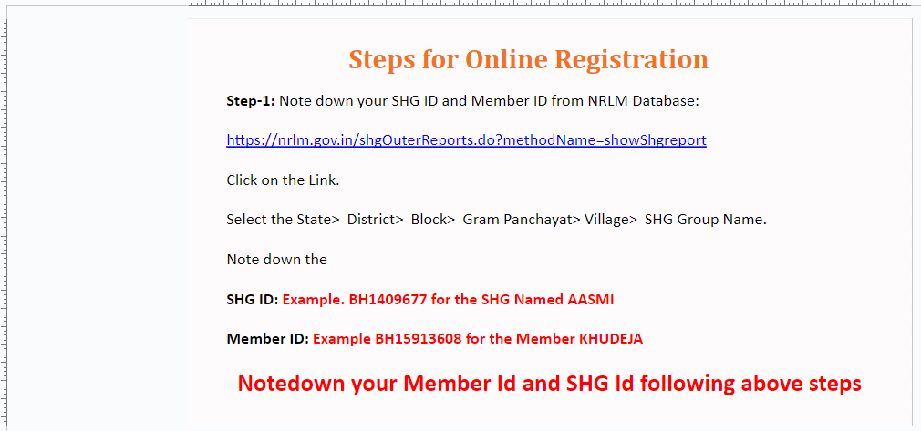
Step 2: Link for member ID and SHG ID is given on the page. Click on the link to collect the relevant information.

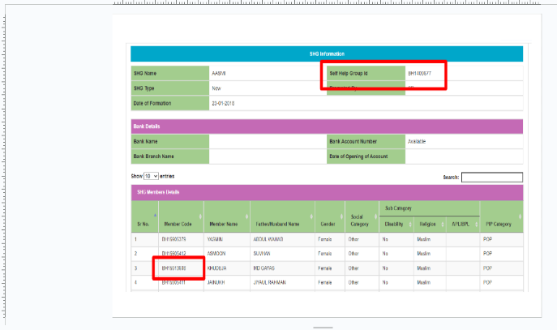
Step 3: Providing other information which are as follows:
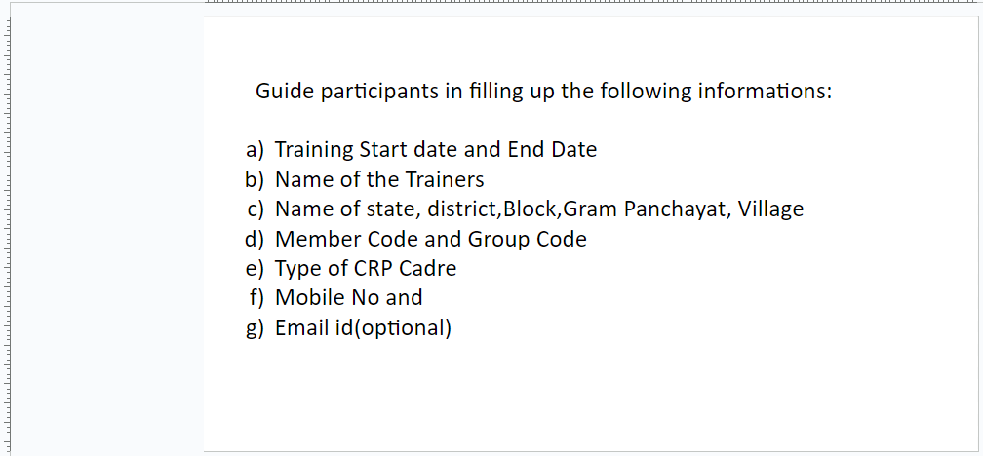
Offline mode:
The information
- SHG ID and member ID
- Training Start date and End Date
- Name of the Trainers
- Name of state, district, Block, Gram Panchayat, Village
Will be provided to the participants. They will be asked to enter their name, which theme of CRP they belong to and their mobile number (preferably whatsapp number) in the format. Filling an email is optional.
In the end the facilitator will thank participants on completion of the required assignment.

Session1: Welcome and Lakhpati Didi training overview
Duration: 30 Minutes
Day 1
Session 1:
Welcome and Lakhpati Didi training overview

Objective: This module of the training is aimed at introduction of the participants and their expectations from the training programme, inform them about training objective and finally the session plan.

Time –30 Minutes

Materials Required: White board, marker pen, Chart paper, Gum/Cello Tape
Methodology: Participatory Discussions
Delivery:
The facilitator shall welcome the participants and ask them to give an introduction about themselves – Name, VO / CLF name.
The facilitator will brief about the Lakhpati initiative to the participants and explain what they will be expected to do at the end of the training programme.
The participants will be asked to share one expectation they have from the training. The facilitator will note the expectations on a chart paper. The similar expectations will be written together on the chart paper. The facilitator shall read out the expectations one by one and note them on the chart paper.
Then discussion will be done on the session plan to achieve the expectations.
Note: The facilitator keeps the focus of the discussion on the output from CRPs and the skill set they require to achieve the same through the training.

Session 2: Concept of Lakhpati Didi
Duration: 30 Minutes
Day 1
Session 2:
Concept of Lakhpati Didi
Objective: This session of the training is aimed at enhancing clarity about Lakhpati Didi, understanding and a sense of appreciation towards -
Action on Ho’ble PM announcement
About Lakhpati Didi
Criteria for selection of potential SHG Didi
Roles and responsibility of CRPs in the Lakhpati process

Time – 30 Minutes
Materials Required: Projector and Screen
Methodology: Presentation by Facilitator
Delivery:
The facilitator shall share the concept of Lakhpati Didi through a presentation which is as follows:
Why this initiative?
Speech of the PM for initiating the livelihood initiative.
2.The facilitator will explain that the objective of Rural livelihoods project is to improve the livelihood of the member households and with the institutions i.e. SHG, VO and CLF are already in place and societal changes like social empowerment of women visible to us, it is time for a project to support members in the livelihood activity of households as well and hence this initiative.
What is the initiative?
The facilitator will explain to the participants that the objective of the initiative is to improve the livelihoods of the SHG member household with an objective of making at least one lakh per annum.
Who will be the beneficiaries?
All the SHG members will be the beneficiaries who (1) are the members of SHG which has completed 2 years, (2) are beneficiary of livelihood intervention under Day- NRLM and (3) have taken CIF loan for livelihood.
In the first phase, the list of expected lakhpati didi will be shared by BPCU with the VO/CLF/lakhpati-CRP.

How will this initiative be taken up?
The SHG members are already involved in the livelihood activities and earning through them. In order to take their household income in the range of one lakh or above per annum, it is required to identify the strength area of their skill and affinity where they can explore new options of livelihood. This may be in upscaling the current activity/ies or diversification of activities or taking up new activities which have a potential of sustaining in the area.
The CRP will have the role of facilitator- support household in identifying the livelihood activities which have potential, troubleshooting the hindrances like constraints of capital, assets, skill or market access by liasioning with the government or private parties. She will further monitor the progress in the implementation of projects.

on 3: Lakhpati Livelihood opportunity
Day 1
Session 3:
Lakhpati Livelihood opportunity

Objective: This session of the training is aimed at introduction of the subject, enhancing clarity on the same and understanding towards –
What is Livelihood for Lakhpati
Potential Opportunities for Lakhpati
How to choose the right intervention

Time – 30 Minutes

Duration: 30Minutes
Materials Required: PowerPoint Presentation on Definitions of livelihood, LCD projector, White board with marker.
Methodology: Interaction with participants through guided questions.
Note to Facilitator
Importance of the session is to encourage participants to articulate their understanding about lakhpati livelihoods and ensure that participants have a working definition of basic concepts on lakhpati livelihoods, potential opportunities for becoming “Lakhpati Didi”, How to choose the right livelihood interventions and preparedness required at SHG HH level for becoming Lakhpati.
Delivery:
Facilitator will welcome all participants and share the objectives of this session. S/he will connect this training programme with earlier inputs provided to the CRP. S/he will ask participants the following Questions:

In your understanding, what is livelihood for Lakhpati?
The facilitator will use the white board and marker or note down the responses in the associated PPT. Each respondent will be asked to share their responses. Respondents may say `/Income/ Living/ Basic Needs/ Cash etc. Whatever the respondents say, note down on the white board / PPT and thank them for the response.
Livelihoods Focus on Lakhpati
Then the facilitator will define livelihoods and explain about livelihood focus in Lakhpati didi initiative and use the following slide for explaining the same:
The facilitator would consolidate the core elements of the definition (like means of making a living encompassing people’s capabilities, assets, income and activities required to secure the necessities of life) and explain how these core elements are crucial for lakhpati livelihoods.

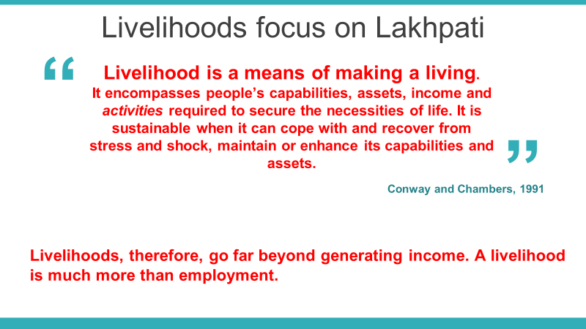
After defining livelihoods using the above slide, the Facilitator will explain how livelihoods is beyond just income generation and much more than just employment.
The facilitator will then ask the following question:
In your village, what are the livelihood activities that families are engaged in?
The facilitator will use the white board and note down the responses provided by the participants.
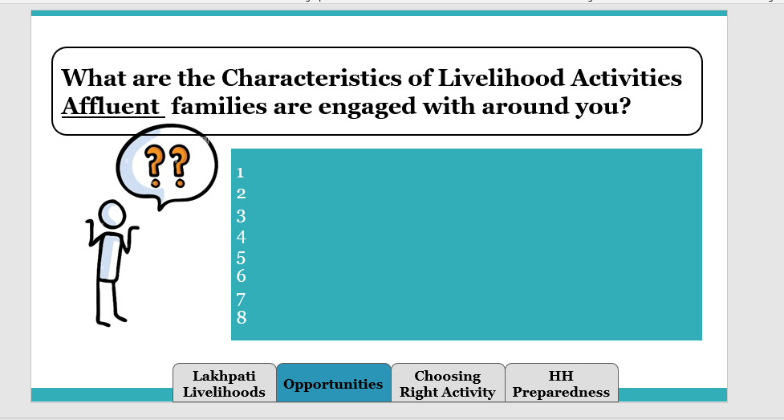
Once the activities are listed, the facilitator will draw seven boxes on white board and write the names of the boxes and explain to them how they are different from each other. Then, the facilitator will ask participants to categorize their list of livelihood activities into the box.
Box-1: Farm – Agriculture: Write all similar agriculture - based livelihood activities.
Box-2: Farm – Horticulture: Write all similar horticulture - based livelihood activities
Box-3: Other – Farm: Write all similar other farm based activities such as bee keeping, mushroom cultivation and the like.
Box – 4: Animal Husbandry/ Fisheries: Write all similar activities which includes rearing of animals/ birds/ fish rearing etc.
Box-5: NTFP: Write all similar activities which includes items collected from forests
Box-6: Non - Farm/ Enterprises: Write all similar activities which are enterprise or business related.
Box 7: Skilling/ Jobs: Write all similar activities which are skill based or generate jobs
Box 8: NRM Works: Write all the activities related to Natural Resource Management strengthening.
After the participants write them in the boxes, ask them to put the title of the boxes (as given above). The facilitator then will consolidate the responses and tell them the 6 categories of livelihoods which are
Farm Based- Agriculture
Farm Based- Horticulture
Other Farm based
Animal Husbandry and Fisheries
Non-Timber Forest Produce (NTFP)
Non-Farm / Micro enterprises and Skills (Manufacturing/ Trade)
Skilling / Jobs
NRM Works
As Natural Resources strengthening like soil and water management are very critical for strengthening most rural livelihoods, Natural Resource Management (NRM) activities are also planned to support livelihood activities.
If the participants have missed any of the categories, the facilitator needs to inform them about the category and a few examples of activities in the category. Then the facilitator needs to show them the following broad list:
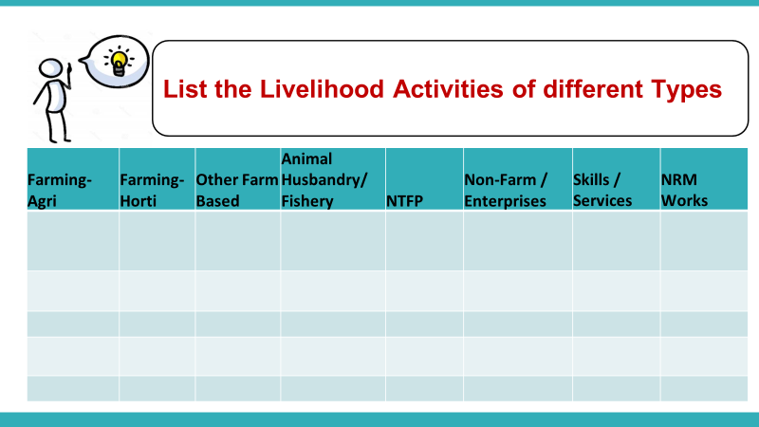
What are your views about a good livelihood activity
The facilitator will ask the participants that according to them what makes a livelihood activity “good” for a rural household. The responses will be noted on the whiteboard by the facilitator.
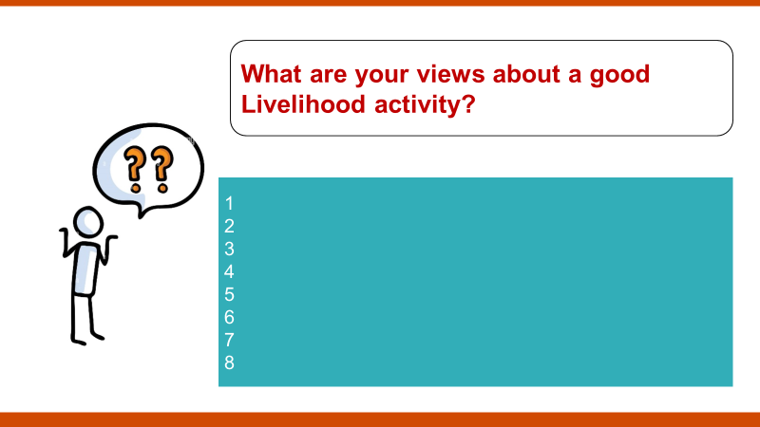
Characteristics of Good Livelihoods
The facilitator will then show the following slide and discuss each characteristic of good livelihoods by linking them to the “lakhpati concept” and how these characteristics enable lakhpati livelihoods for SHG members.
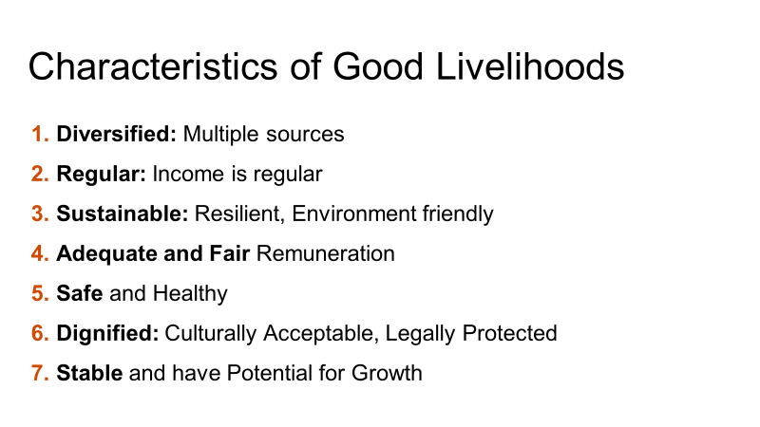
Factors Determining Livelihood Choices
The facilitator will then discuss the factors that need to be considered by the SHG HH while determining livelihood choice making.
The 5 factors that determine livelihood choices are:
Asset
Ability
Accessibility
Affiliation
Attitude
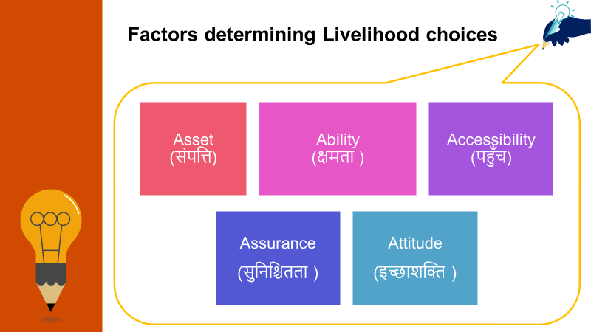
Affinity
(network)
The facilitator will explain each of these factors and how they affect livelihood choice making by the HH.
Potential Livelihood Activities
The facilitator will then lead the discussion towards the potential livelihood activities that the SHG HH can choose from. Before discussing the options of LH activities. The facilitator should discuss about the 2 essential elements that the family must consider while selecting their livelihood options
HHs are interested in the activity and have the capacity to undertake the same based on the factors discussed in the previous section
Market Led activities i.e there is a good demand and potential for the sale of the produce, product or service
The facilitator can give one or two examples of how these two elements can enable better decision making for livelihood choices for a HH.
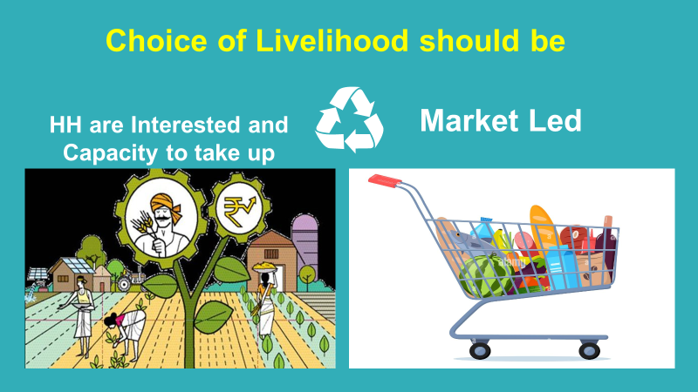
After discussing these points, the facilitator will show slides 14- 39 which essentially show the specific examples within the 8 types of LH activities that were discussed in the beginning of this session (Point No. 3 in this session)
How to choose the right livelihood interventions for becoming Lakhpati Didi
The facilitator will then give an overview of the topics discussed in this session and ask the participants to share their key learnings from the session and write them on the whiteboard.
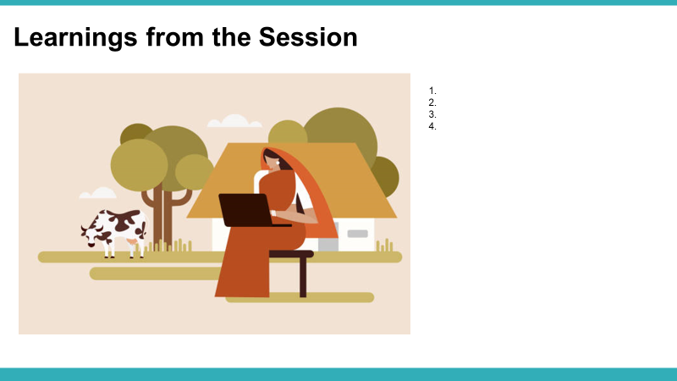
The facilitator will thank the participants for their concentration and active participation during the session.

Session 4: Lakhpati Livelihood Planning
Session 4:
Lakhpati Livelihood Planning

Objective: : This session of the training aims to make participants understand the different components of Livelihood Planning.
Understand how people take decision pertaining to livelihoods options in their lives.
Understand and appreciate the role of “ASA” in the life of a poor family

Duration: 30 Minutes
Materials Required: PowerPoint Presentation on Definitions of livelihood, LCD projector, White board and a marker.
Methodology: Use of PPT and Participatory Discussions
Note to Facilitator: Facilitator will ask participants to discuss and share the key factors that are important to a SHG HH while they plan their livelihood activities. The facilitator will note the responses on the whiteboard.
Questions to consider during Livelihood Planning for SHG Households.
The facilitator will then show the below slide and talk about the 3 key factors that must be considered while conducting planning with SHG HHs
WHY? The SHG HH should explore additional livelihood options
WHAT? Factors a family considers while planning livelihoods
HOW? Lakhati Planning is done to enable them become Lakhpati

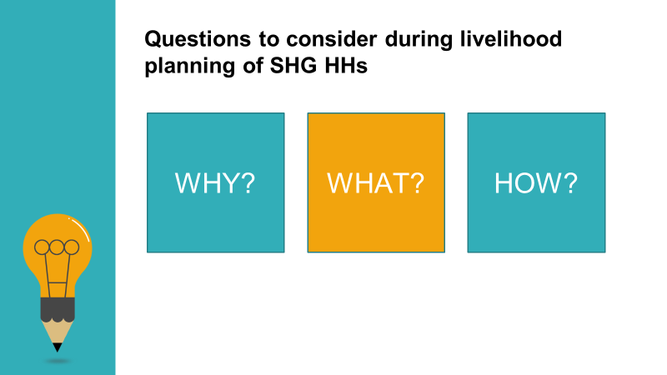

Why should the SHG HH explore additional livelihood options?
The facilitator will initiate a discussion with the participants around the question: Why should the SHG HH explore additional livelihood options? Once the participants have shared their responses, the facilitator will show the following slide and explain the process described as follows:
The HH must aim for an increase in their income. The second question that arises is “How much income?”. The facilitator shall explain that a family which earns a monthly income of 10,000 per month or more which is sustained over 3 seasons or an annual income of one lakh or more.
The facilitator will then discuss, what will be the purpose for which this additional income can be utilised by the HH and what difference can it make in their lives.
The purpose is to enable the SHG to become “Lakhpati”. A Lakhpati HH will be able to live a life of dignity which is much more than just subsistence living. The benefits of additional income can be in the form of better education for their children, better standard of living, financial stability, better health etc.
The facilitator can ask the participants what other benefits that the HH can have with the additional income they earn by becoming “Lakhpati”.
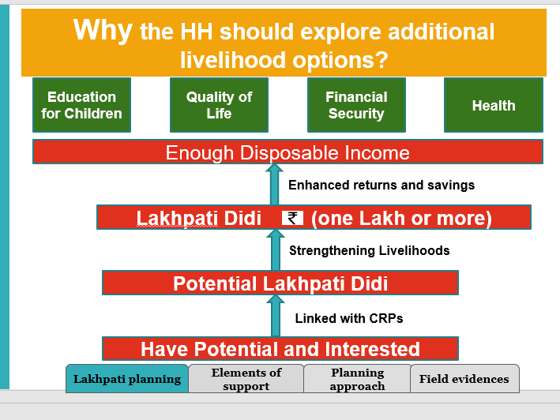
What Factors a family must consider while deciding the Livelihood Options?
The facilitator would then show the following slide and ask the participants to divide themselves in 3 groups and give the task of listing the key factors that the SHG HH must consider while planning their Livelihood Activities. The facilitator can give reference to the previous session in which these factors were discussed.
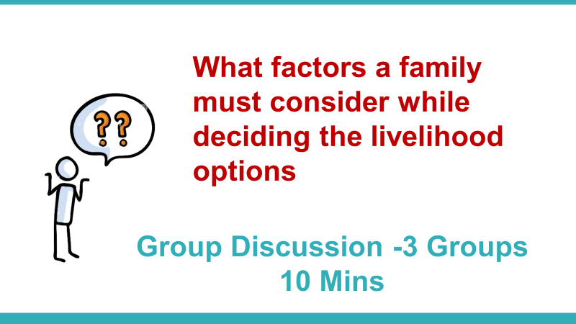
After the group discussion is over, the facilitator shall ask each group representative to share the key points of their group’s discussion and list them on the whiteboard.
The facilitator will then try to summarize all these in 5 A’s framework- Ability, Access, Assets, Attitude and affiliation.
Further discussion on the support required for each activity will lead to ASA , which is the support required from outside and includes:
Assets
Skills/ Knowledge
Access to Finance and Access to Market
After the summarization, the facilitator will say that these are the three determining factors for livelihood planning at family level. These three factors can be called “ASA”.
The facilitator shall then discuss the 3 factors that determine livelihood choices
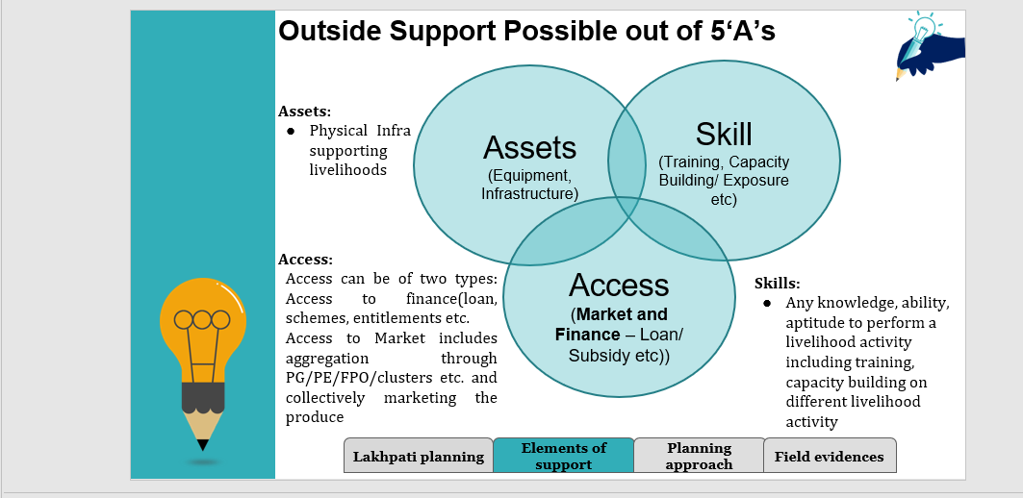
The facilitator will give examples of each of the three factors for better clarity and understanding of the participants.
Assets: Any physical object useful for livelihood activity, which include three broad categories:
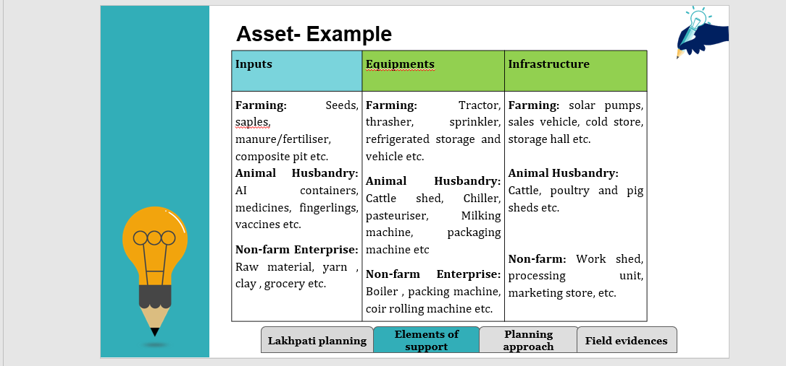
Skills: Any knowledge, ability, aptitude to perform a livelihood activity. This includes Training and Capacity building on different livelihood activities.
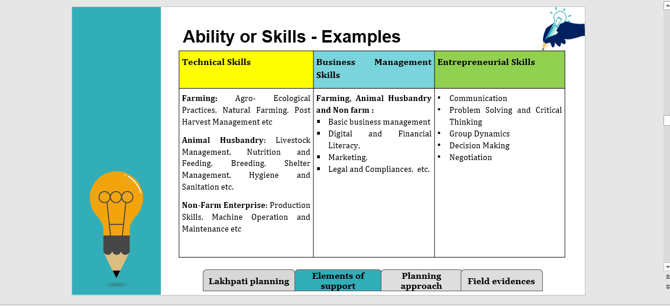
Access: Access can be of two types. Access to Finance includes loan, schemes, entitlements etc. Access to Market includes participation in FPO/ Producer Group/ producer Enterprise /clusters and collectively market the produce. The market will have an important role. Therefore, branding, packaging, advertising needs to be understood by them.
- Loan (eg. Bank linkage, Mudra, etc.  - Schemes (State & Central Govt)  - Department Support (Eg. MGNREGS/other deptt support) | - Access to market through membership in business organisations like PG/PE/FPO/cluster etc.  - Private partnerships  - Linkage with star ups  - E- commerce  - Rural marts  - Local haats and markets
Access - Examples
How to do Livelihood Planning to reach an annual income of 1 lakh and above?
The facilitator will initiate a discussion among the participants on the differentiators between a SHG woman and Lakhpati Didi. He may use three broad aspects for these differentiators – Cropping, Adoption of Technology/ Package of Practices and Type of Activities. By using some examples, the facilitator shall lead this discussion for developing clarity among the participants.

How to do Livelihood Planning to reach annual income of 1 lakh+
Particulars | SHG Member | Lakhpati Didi
Type of Cropping | Mono crop | Multiple crops for different seasons (Kharif/Rabi), Zayad; Marketable & quality-oriented crops
Method/Approach | Conventional way of farming with few modern techniques | Adoption of technology and standard package of practices (Management of productivity)  Value chain intervention
Type of Activity | Agriculture & allied activities | Diversified Activities  Agriculture  Horticulture  Livestock  Non Timber Forest Product

Once this discussion is over, the facilitator will use an example given in the following slide to explain how an annual income of 1 lakh and above is possible for SHG women to become Lakhpati using diversified livelihoods and adoption of technology / Package of Practices for identified livelihood activities
5. Approach to livelihood selection
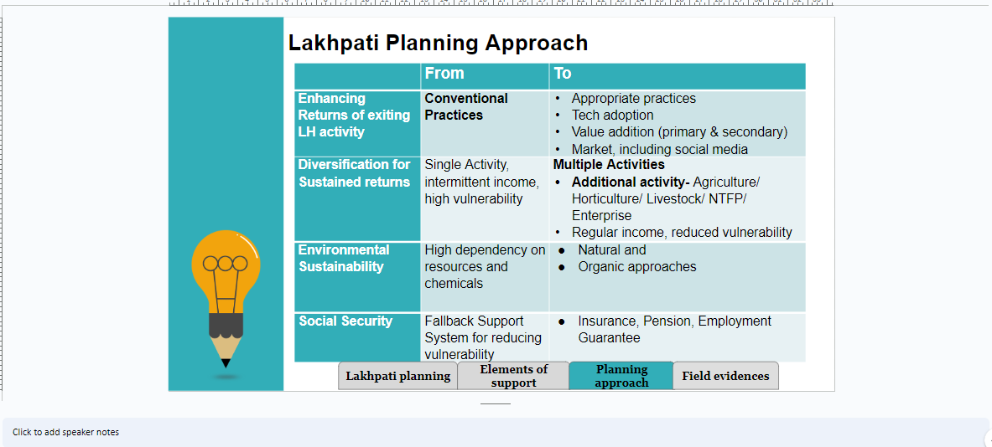
The facilitator will explain how households should switch from conventional practice to modern practice which includes use of technology to enhance productivity. But the risk involved and additional capital requirement to adopt new techniques must be considered and taken.
He/she should further suggest involving in multiple activities instead of upscaling single activity is advisable as it reduces the risk of vulnerability i.e. in case of failure of availability of factors of production if the intervention fails then the risk to the income from existing livelihood is very high.
He/she should inform the participants that while planning livelihood the sustainability of the activity should be kept in mind i.e. the natural resources which are being utilized are ono replenishable and hence optimal use should be planned. Secondly, use of harmful and excess chemicals should be avoided as it affects nature as well as the consumers both in the long run.
Apart from selection of the activity, information regarding provisions of social security i.e. insurance, pension etc should be considered as it reduces the risk in case of failure of crops or some other natural calamity.
The facilitator will then use the consecutive slides in the PPT (including examples) to share various types of examples of different Livelihood Activities from Broad Categories to explain how 1 lakh annual income can be reached through adoption of these activities. Further, the facilitator shall give real examples from the field where SHG women have adopted these activities and practices and have become “Lakhpati Didi”.
Household Level Preparedness before Lakhpati Planning tool
The facilitator shall then discuss the preparedness required at the SHG HH before planning their livelihood activities. The facilitator shall discuss the following points one by one and initiate discussion among the participants on each of these points:
- The family must decide which livelihood activity/ activities they are planning to take up
- The requirement of Asset/ Skill/ Access to be identified in consultation with the CRP
- Aware of the cost/finance required for the activity
- Aware about the risk (Production risk, market risk) associated with the livelihood activity.
- Aware about the cost of production and profit going to earn through the activity.
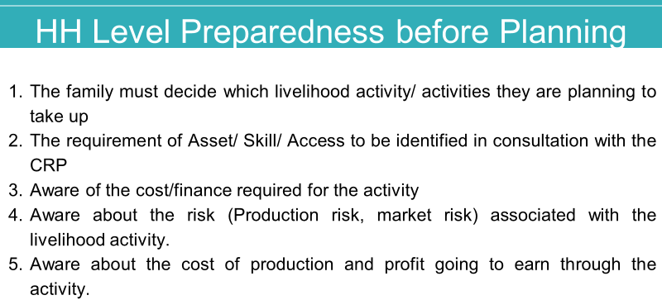
Group Activity: identify the different requirements for Livelihood Planning
The facilitator will divide the participants into groups and hand out the cost estimates required for various livelihood activities – Each group will be given one livelihood activity. The group members will be asked to identify the different factors required for the particular livelihood activity. This analysis will be a part of the Livelihood Planning exercise that CRPs will undertake with SHG member HHs in order to identify and finalise the livelihood activities they wish to undertake. Each group shall present their work at the end of the session using the format given in next slide
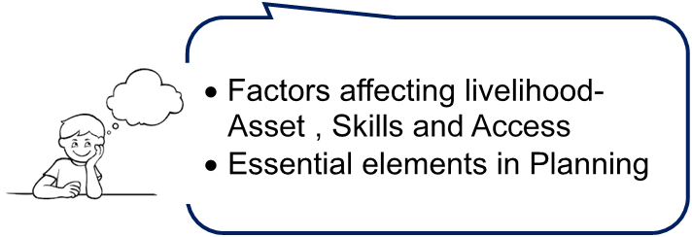

The facilitator will now give handouts of the Livelihood Prototypes (Cost Estimates) of any three Livelihood activities. Each group is provided with a different cost estimate. The participants will be asked to refer to the handout and prepare their requirement list in six rows for each of the plan:
Name of the Livelihood Activity
ASSET | Input
ASSET | Equipment
ASSET | Infrastructure
SKILLS | Skill Training/ Exposure Visit
ACCESS | Access to Finance
ACCESS | Access to market

The facilitator will allow 10- 15 minutes to the participants and ask them to list out the demands in the above table.
************

Session 5-Lakhpati planning process and tools
Duration: 30 Minutes
Day 1
Session -5
Lakhpati planning process and tools
Objective: Through this session of the training, the Lakhpati CRPs will have enhanced knowledge and understanding about the following:
Process for Lakhpati Livelihood Planning
Steps for Livelihood planning with Lakhpati Didis
Pre- planning steps for Lakhpati-CRP
Overview of Components in the Lakhpati Planning Format
Group Exercise

Materials Required: chart papers, sketch pen, cello tape,
Methodology: Presentations by Facilitator, Group Activity.
Delivery:
1.Process for lakhpati livelihood planning:
The facilitator will explain how the process of implementation of livelihood planning will initiate.
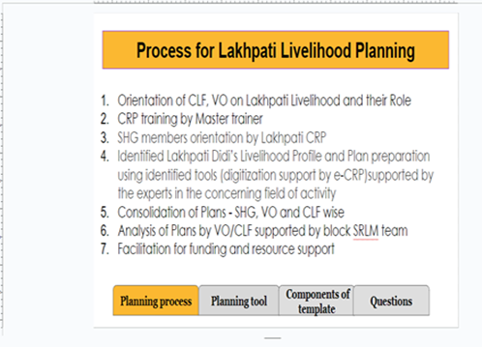
In the first step lakhpati CRP will be oriented on the initiative by a master trainer who in-turn will orient VO/CLF about the initiative and steps which have to be taken in its implementation.
2.Steps for CRP to initiate livelihood planning with lakhpati didis
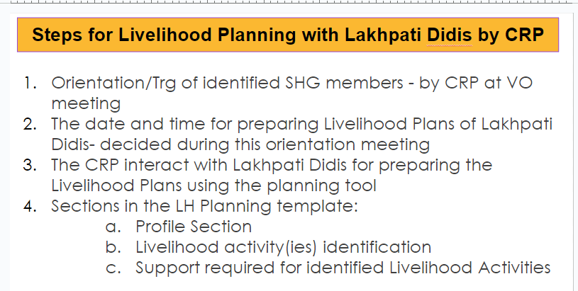
The facilitator shall begin this session by explaining one step after another through which she will be able to create the livelihood plan of the household. During orientation of VO members, the lakhpati-CRP will fix the date and time of meeting with potential lakhpati SHG members at a scheduled place for a livelihood plan. In the process,
i.SHG members will be informed about the potential livelihood activities of their area.
ii. they would be advised to discuss it with their family members before coming back to fill up the planning template on the scheduled date.
iii. The CRP will fill up planning tool for SHG Didis after discussing with them
The facilitator will explain about the components of livelihood planning tool:
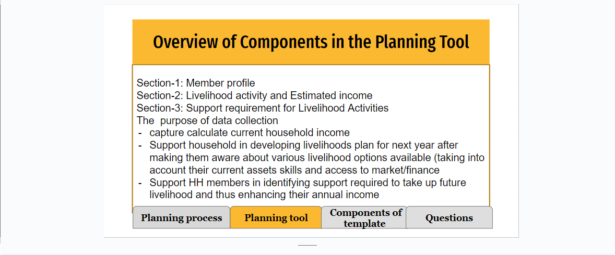
- Member profile
- Identification of livelihood activities and calculation of net income from each activity
- Identification of support required for implementation of each livelihood activity
i. Member profile: The facilitator shall first explain the rationale for member Profile. The facilitator will explain that to facilitate the generation of the future requirements and a bird eye view should be kept on the current livelihood profiles of individual HH, a household level profile will be created for each of the SHG member in the planning tool.
The facilitator will then ask the participants – “What should be the process for preparing the livelihood profile of SHG household”?
The facilitator shall ask a few participants to share their understanding about the process of member profile preparation for SHG. She will note all the points suggested on the white board and avoid repetition of the suggested points.
Profiling, understanding interests and available livelihood options for SHG members
Understanding and noting down the profile of a Household member, after broad discussions and identification of the livelihood activities, the member is supposed to discuss the options with their family and come back in the next meeting for the second phase. They will also be appraised of how they plan and what information they need to work on for detailed planning.
Understand what is the current activities, credit profile, and business affiliation of the member (HH profile)
Understanding the requirements/need of household (whether she is satisfied with her current livelihood activities or has some issues to be addressed), considering current status of the Household
Discussing possible livelihood options based on 5A framework.
Then the facilitator shall share the following process of Livelihood Profile preparation for each SHG member:
Prepare a schedule with date and timing for all the SHGs during VO orientation meeting for preparing the Livelihood Profiles of SHG Members
During the VO Concept Seeding, the rationale for creating SHG members’ livelihood profile must be shared with the SHG representatives attending the VO Concept Seeding (Rationale is mentioned in the box above - Outline and Rationale of SHG Member Level Profile creation).
Prior information must be given to the SHG members about the date and time of meeting for creating the livelihood profile. This information will be shared with the SHG members by the SHG representatives attending the VO orientation Meeting.
The CRP shall create the Livelihood Profile of each SHG member in the pre - decided meeting of the respective SHG.
The CRP shall ask the required questions to each SHG member as given in the livelihood planning tool and feed the information in the given format.
ii. Identification of current and planned livelihood activities and calculation of net income from each activity:

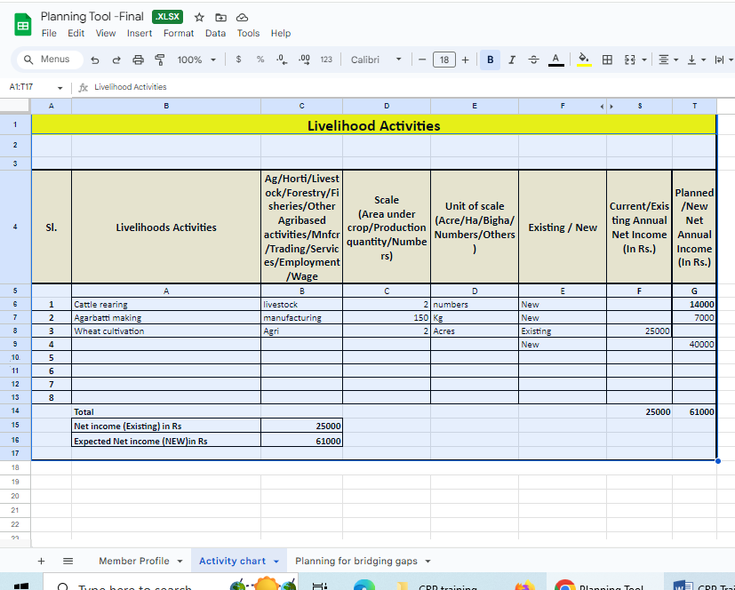
The SHG members and their family members are already involved in livelihood activity/ies in the current year. Based on their need and interest, they are willing either to upscale current activities or take up some new activities.
Further they would elaborate on the risks in the business and expected net income through the experts who will be involved in the planning process.
iii. Identification of support required for implementation of each livelihood activity:
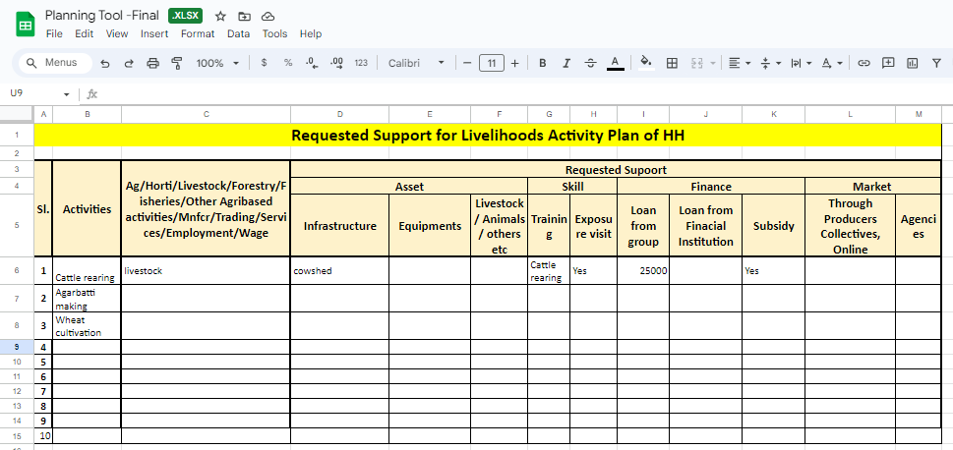

The livelihood activity(ies) which have been identified for next year, need some support -ASA. The SHG members identify the support that they need to implement the planned livelihood activity(ies) which may be in the form of asset, skill or access to market and finance.
The facilitator may help CRPs in resolving any queries while they create the profile in the livelihood planning tool.

Handholding of Lakhpati Didi and role of stakeholders
Duration: 30 Minutes
Day 1
Session -6
Handholding of Lakhpati Didis and role of stakeholders
Objective: This session of the training is aimed at developing knowledge and skills of livelihood CRPs on the following:
What is handhold?
Why handhold is required?
Role of CRP in lakhpati process
Role of VO/CLF
Role of block/district/state team
TTime – 30 Minutes

Materials Required: White board and marker pen, Writing pad and pen
Methodology: Presentations by Facilitator
Delivery:
What is a handhold?
The objective of this programme is to convert potential lakhpati didi to actual lakhpati didi.
It has been realized that the facilitation process in making lakhpati should not be limited to providing financial assistance and linkages to various agencies for different types of activities but personal touch is also required for favourable results.
Why is a handhold required?
- Understanding ground realities
- Bridging gap
- Ensuring sustainability
The above example of the participation of SHG members in SARAS fair the challenges were identified in the form of (i)booking tickets to the venue of saras, (ii)packaging and carriage of goods to be carried for sale (iii) Producing required documents for allotment of shops for SARAS (iv) capacity building for decorating the shops at par with their competitors.
Live example - In the initial stage of NRLM a project staff accompanied Didis when they went to participate in the saras fair across the country. The role of the project staff was to support Didis during the journey i.e. book reservation tickets in train, support them in packaging of items to be sold at fair, in the documentation process for allotment of shops at fair site and advise them in setting up the allotted shops during in the fair. Gradually, Didis became aware of the process and started participating in saras without any support from the project.
The facilitator will point out the places where bridging gaps was to be done for facilitating SHG Didis participation in saras and will emphasise that same efforts are required in this case and Lakhapti CRPs will take up multi facet responsibility to support the Didis.

The Standard Operating Procedure was developed for participation in SARAS, the capacity building of participating SHG members was done on the above stated topic by the project team and gradually they were able to participate in the SARAS without any assistance from the project team.
How effective hand holding will be done?
The facilitator will discuss the participants on the following points:
1. Why did they join SHG?
All the SHG members became part of SHG based on their different perception about SHG roles in resolving issues related to their life.
2. What were their inhibitions while joining SHG?
Understanding Didi’s aspirations and fears: The inhibition of attending meetings, contributing to the revolving fund etc.
3. Was there any yardstick to measure the effective running of SHG?
- Monitoring progress, feedback to Didis for improving its status: “Panchsutra of SHGs”
- Now the facilitator will relate the formation of SHG with the handhold of the lakhpati and conclude that the same is applicable in this case.
- He/she would discuss that Lakhpati would be successful if
- CRPs recognize the unique needs of each household in the planning process and support them in the livelihood selection for the next year.
- CRPs understand their aspirations and fears of households in taking up livelihood interventions and address them with support of CLF/BPCU.
- CRPs regularly monitor the progress of the implementation plan of each household and discuss with them about the progress and try to troubleshoot challenges, if any. Once the livelihood intervention is launched by the family, details of the same should be reflected in the aajeevika register.
Role of different stakeholders:
The facilitator will elaborate the team about the roles of various stakeholders in the lakhpati initiative which is as follows:
The Role of CRP - pivotal and multi-dimensional role in the lakhpati initiative which includes the role of facilitator, trouble shooter, capacity builder and monitor.
It has been assumed that CRP will support SHG household in the
(i)Planning process
(a) lakhpati planning process after getting required training skills
(b)Collate the data in planning tool i.e. SHG member profile, selecting livelihoods option for next year and support required for taking up new livelihood activity
(c) present the collated data to VO/CFL /BPCU for further action
(ii) Post plan process:
- complete the documentation process to apply for a loan from the banks to support SHG households to get financial support etc.
- Inform CLF/VO to place for convergence with government schemes with the support from the Block/district team of SRLM.
- CLF/VO to organise training for SHG households based on their demand in the planning tool of livelihood.
Role of CLF:
i.The consolidated SHG household plans will be presented to CLF for support in expedition of the same.
ii.CLF will ensure resource availability for LH activity through CBOs (RF/CIF)
iii.The requests will be submitted to line departments for remaining planned activities for which support is required. Coordination and follow up for the same would be done.
iv.Monitor timely initiation and completion of work.
Role of VO:
During planning:
(1) Plan and Monitor the progress work of CRP: Orient SHG members and (2) Consolidation of plans of households
(3) Present Plans in Gram sabha
(4) Integrate with AAP of NRLM and GPDP for resources
(5) Coordinate with CLF for further support
During implementation
(1) Monitor, facilitate and support the implementation of the LH activities planned by the SHG households.
(2) Supervise guide and facilitate CRPs
(3) Follow up with the relevant department /entity, if required
(4) Prioritize allocation of CIF for livelihood activities taken up
Role of block team:
Participation of block team in presentation of consolidated data for support required by SHG household for lakhpati initiative:
The experts from the block team should be present in the CLF meeting for preparing AAP and share the same with the district team.
Direct interaction with Lakhpati- CRPs and availability of resources for activity of CRP:
The nodal persons from the block team should be interacting with Lakhpati CRPs on the regular basis and provide them with the required resources for achieving the desired goal. They will guide VO/CLF to prioritise lending of loan through CIF to the members proposing livelihood activities.
For ex.- A CRP may come across questions from SHG household for which she is finding difficult to answer. She may contact the concerned block person for required support.
Secondly, the CRP may seek support for finding local thematic experts/agencies to guide them/household, converge with line departments and fulfill required processes and procedures in applying for them. Further, allocation of fund for livelihood activity of the block in the annual action plan
Local training and capacity building: The block team, with support from the identified local experts/agencies (KVK/KVIC etc.), may take up training programmes for different thematic as per the requirement of the household.
Role of district team:
Review the livelihood plan prepared by CLFs: The district team will review the plan prepared by CLF and shared by the block team and give their feedback to them.
Information and resource flow management: After assessing the support activities identified in the Lakhpati planning tool for the lakhpati household, the district team would suggest them on the source from which finance, assets, skill and market would be managed. This includes convergence with the line department, monitor disbursement of CIF and bank linkage, adding different agencies to the value chain for supporting SHG households /producer collectives.
Help blocks in implementation by developing supportive system like provisions of revolving fund for producer collectives of different livelihood activities, pool of experts/expert agencies for livelihood plan implementation by training them for good practices, providing inputs on new technologies and supporting them in making their units functional.
Regular feedback from block teams and CRPs on the improvement of the support system is crucial for fast and systematic implementation of plans.
Collaboration and partnerships: For implementation of livelihood plan collaboration and partnership is required for agencies working on different steps of the value chain. Identification of such partners and developing mode of operation in sync with the operation of entrepreneurs/producer collective is very important for the success of the programme.
Use of technology for fast information dissemination between district, CRPs and block teams is another important step for reducing time lag of implementation.

Role of state team:
Policy framework and system alignment: Policy of the SRLM should be in place for different livelihood interventions for defining modus operandi of the producer collective activities, provisions in budget for Revolving Fund for all the livelihood sections, capacity building of project staff and community cadres and Lakhpati SHG members and integrating with the roles and responsibilities of the existing project staff and recruiting new staff, if required. Further partnerships with other agencies will also be a part of it.
State team can assess the resource requirements of the different blocks for different livelihood activities and support the district team for different components i.e.
i. availability of funds as revolving fund for collective livelihood activities, prioritising use of CIF for livelihood activities by the SHG members
ii. Create a pool of experts from different departments / expert agencies for training of project staff, community cadres and supporting livelihood activities of the SHG households individually and as producer collective.
iii. converging with different national level programmes of different departments and making it available for supporting SHG.members.The state team should develop a system for monitoring the progress in the lakhpati programme and provide required support and give suggestions in the implementation and address the challenges.
Identification of innovations and best practices for different interventions across districts, documenting them and creating awareness in the district team, block team and CRPs through different mediums like videos, success stories and exposure visits will be very supportive.

Session 7: Resource provisions
Day 1
Session -7
Resource provisions
Objective: This session of the training is aimed at enhancing the knowledge and skills of Livelihoods CRPs on the following:
They should be aware about the different government schemes being implemented on the ground through different government departments.
The models showing convergence through various agencies for implementation for livelihood activities is depicted
Process of documentation for convergence for a particular activity is shown
Time – 30 Minutes

Duration:30min.
Materials Required: Laptop, projector, ppt
Methodology: Presentation by facilitator
Delivery:
Convergence schemes and missions by different departments for different activities is done, detail of which is as following:
Day NRLM
Schemes of Rural department
Finance from banking institutions
Schemes from ministries department and private sector
The schemes under Day-NRLM could be Mahila Kisan Sashaktikaran Pariyojana, Intergrated Farming Cluster, institutional promotion of producers, sub sector promotion, innovative projects in farm sector, micro enterprise se development, SVEP, One stop facility center, product and sectoral product promotion and incubators etc.
Bank finance schemes under Day NRLM includes the following: 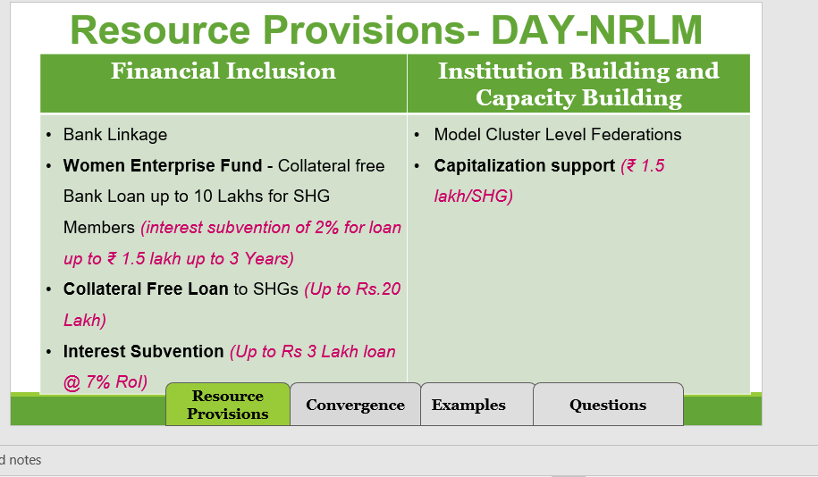
The schemes under Rural development are as follows:

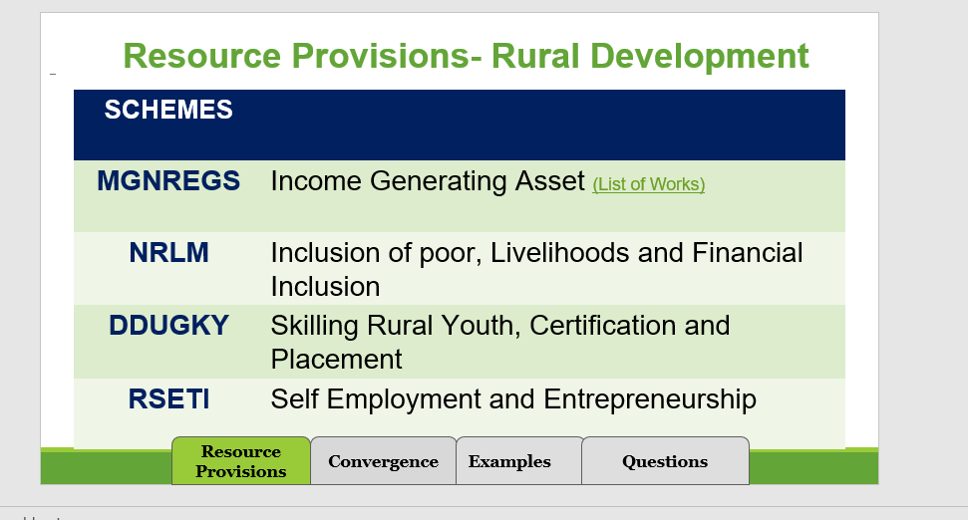
DAY NRLM
Resource provisions under other ministries includes the following:
Examples:
Agriculture & Horticulture:
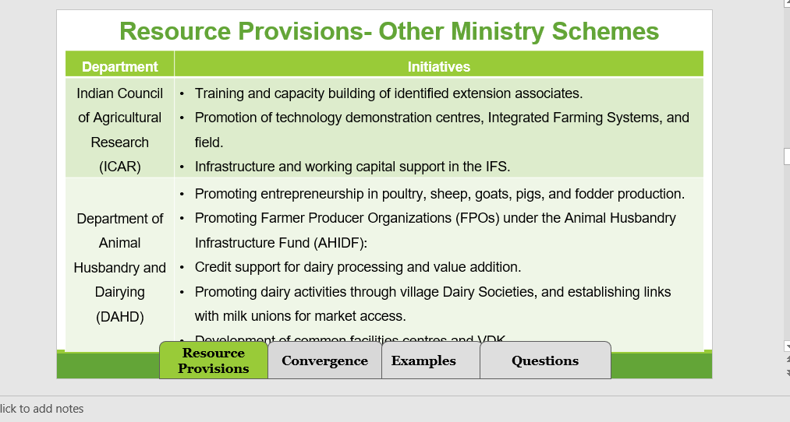
The scope of convergence under various schemes includes:
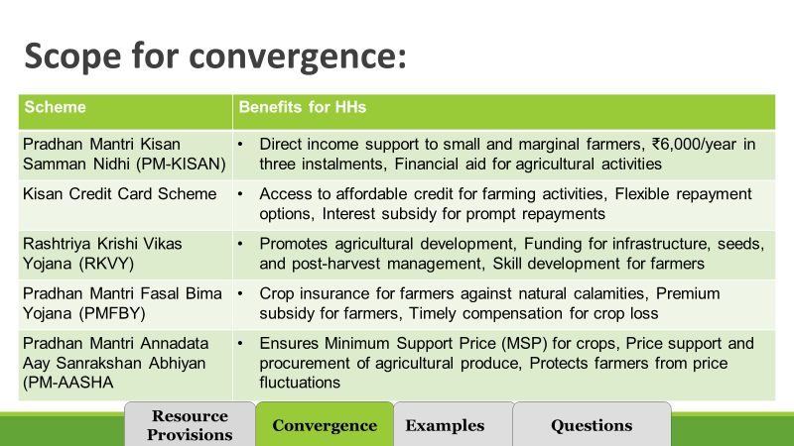
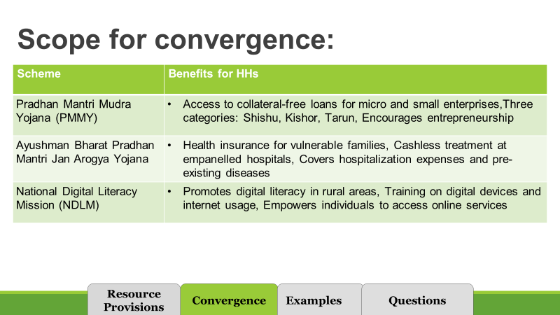

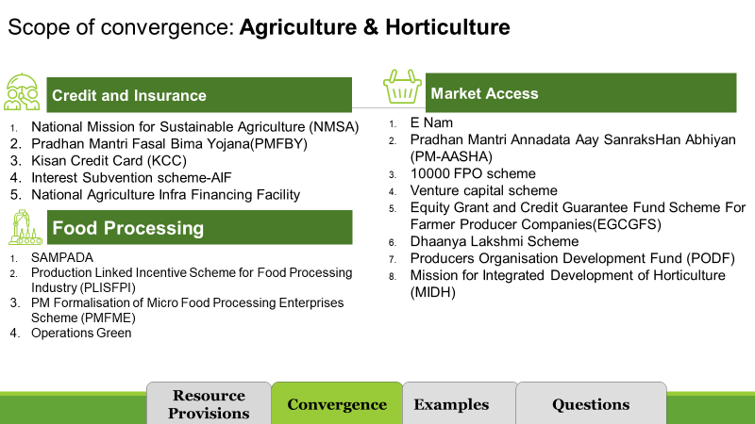
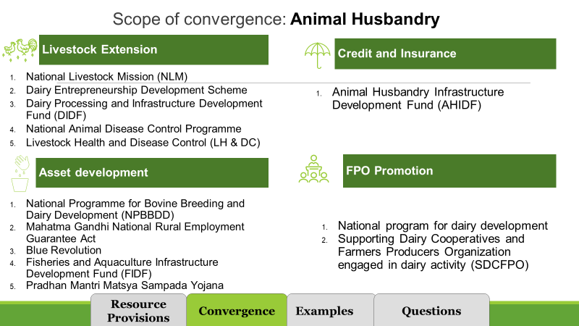
Example of convergence:

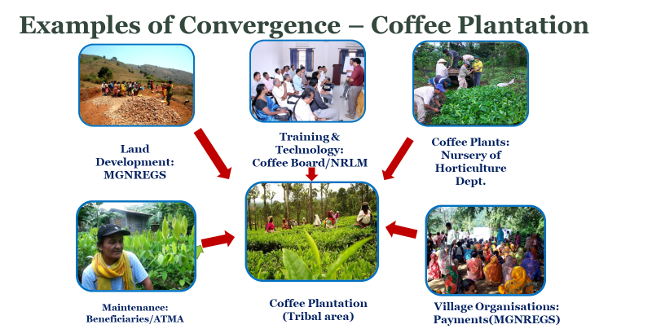
Case study: In this intervention on coffee plantation the coffee plantation was undertaken in a tribal area where payment for land development was done under MGNRES through village organisations, the coffee plants were provided from the nursery of the horticulture department, training and technology was provided by the coffee board with support of NRLM. The maintenance of the plantation was done by the beneficiary with support from ATMA.
This is a good example of convergence with multiple stakeholders for successful implementation of a livelihood project.
The facilitator will motivate the CRPs that such successful interventions after convergence with multiple stakeholders can be undertaken in the future with due support and involvement of district and state NRLM teams.

Session 8 Aajeevika register
Day 1
Session- 8
Aajeevika register
Objective: This session of the training is aimed at enhancing the knowledge and skills of Livelihoods CRPS on the following:
Purpose of aajeevika register
Content in aajeevika register
Identifying income source of the family
Calculating net income from the activities after deduction of expenses incurred from the gross income
Steps for implementation
Time – 45 Minutes

Duration: 45 Minutes
Materials Required: White board, marker pen, projector, laptop
Methodology: presentation by facilitator, group activity for filling of ajeevika register
Delivery:
The facilitator will inform about the purpose of aajeevika register:
1.The aajeevika register will record the location of the SHG, its ID in MIS, name of SHG member and their ID
2.Revisit the livelihood activities undertaken for aajeevika by the SHG members in the current year
3.Identify different income activities at the household level
4.Calculate net income after deducting expenses incurred in the activity from the gross income from the sale of that product(s).
1.The source of income for SHG households could be defined from the following slide.
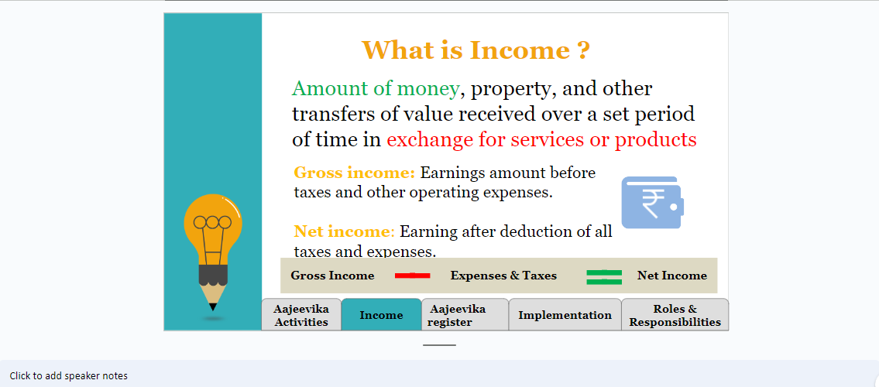
2. Calculation of net income:
Manufacturing sector:
Calculation of Gross income from the manufacturing, trading or services could be the amount received from the customer against product or services. The expenses incurred in carrying out the activity will be deducted from gross income for calculating net income.
Agriculture sector: For the agriculture sector the source of income and allowable expenses are given in the slide.
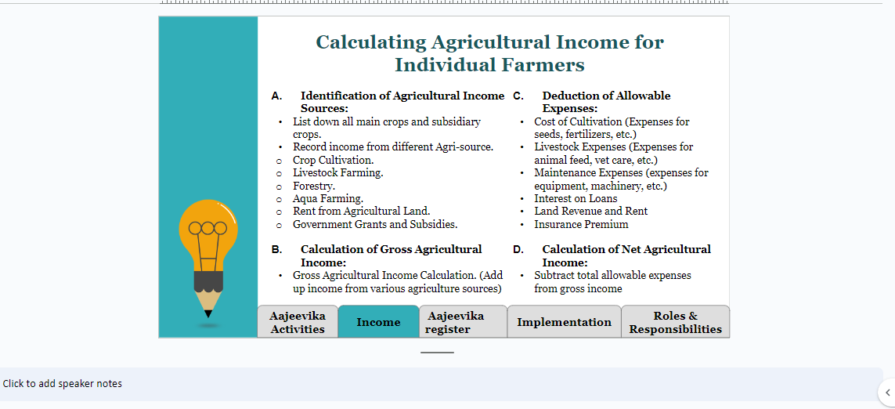
5. Steps for implementation is discussed below:
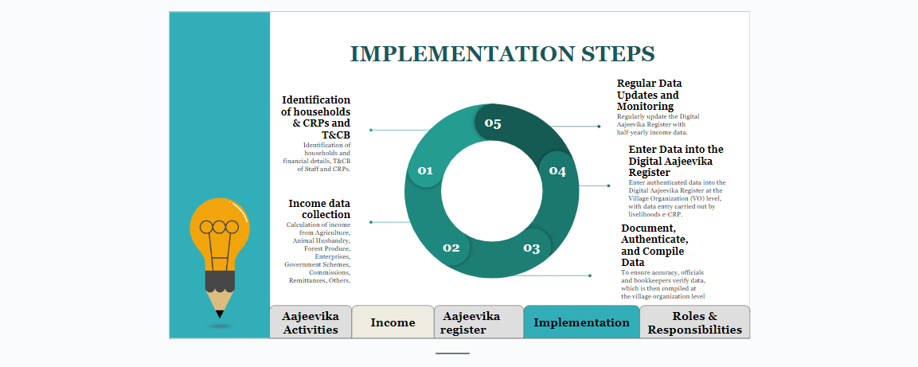
6. Steps for data collection
Training and capacity building of concerned staff at State, district and block
The VO will Identify and train the Livelihood e-CRPs/Data entry Sakhi for data management.
Livelihood e-CRPs will be responsible for collecting data of all the members.
The data will be entered into the MIS portal
A committee consisting of District manager MIS and livelihoods will monitor the above process.
The data has to be collected on half yearly basis after the crop harvesting.
Third-party evaluation will be conducted on regular intervals to check the authenticity of the data.

The steps for data collection from identification of Lakhpati- CRP to data entry by operator at CLF level is discussed.

Recap of Day
Day 2
Recap of Day
Recap of Day 1 Session
Time – 15 Minutes
Duration: 15 Minutes
Materials Required: white board, marker pen
Methodology: Participatory Discussion
Delivery:
The facilitator shall give a recap of the sessions of Day 1 and ask the participants if they have any questions / doubts about any of the sessions / topics covered the previous day. The facilitator shall respond to the queries / questions of the participants
In the process, the facilitator will motivate participants to recall the topic discussed yesterday and he/she will note them one by one till all the topics are covered.
The facilitator will thank the participants for being attentive in the session and would ask them to maintain the same level of attentiveness for the forthcoming session.

Session9: Social Security Schemes
Day 2
Session 9
Social Security Schemes
Objective:
The objective of this session is to provide information to VO/CLF /CRPs/SHG household on various insurance schemes to mitigate risks in various forms and livelihoods activities.

Time – 25 Minutes

Duration: 30 Minutes
Materials Required: Chart paper, Sketch pens, projector, presentation
Methodology: Participatory
Delivery:
The facilitator will discuss with the participants about the various forms of risks that exist in the life of SHG household which includes risk of minimum income, death of family head, security from health risk, risks on livelihood activities like crop, livestock.
The facilitator will inform about various insurance schemes which are given below:
MGNREGS: The benefits in the scheme, eligibility criterion along with the term and conditions of the scheme will be discussed.
Benefits
Entitled to work for 100 days per household per year
Wage rate differs from state to state
Eligibility: Any person above age of 18, residing in rural area and volunteer to do unskilled work
Entitled to receive work within 15 days of demanding work
If work is not provided within 15 days, applicant entitled to unemployment allowance (1/3 wage rate for first 30 days and half the wage after 30 days)
Work to be provided within a radius of 5 km of applicant’s residence (Travel allowance must be paid if more than 5km)
Whom to approach: Job card application from Panchayat office. An individual may appear personally before the Panchayat Secretary or Gram Rozgar Sahayak and make an oral request for registration.

Health insurance:
Pradhan mantri Jan Aarogya Yojana:
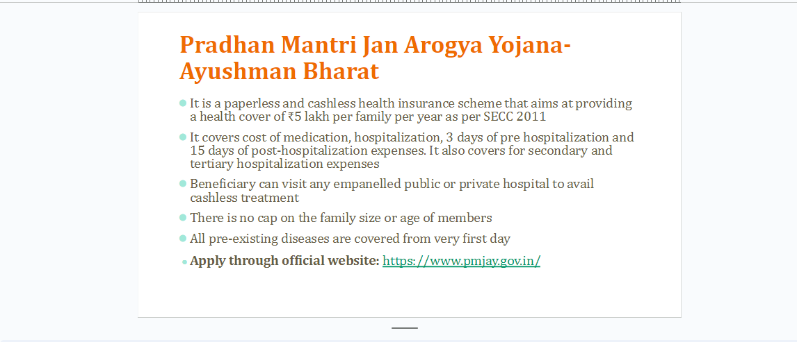
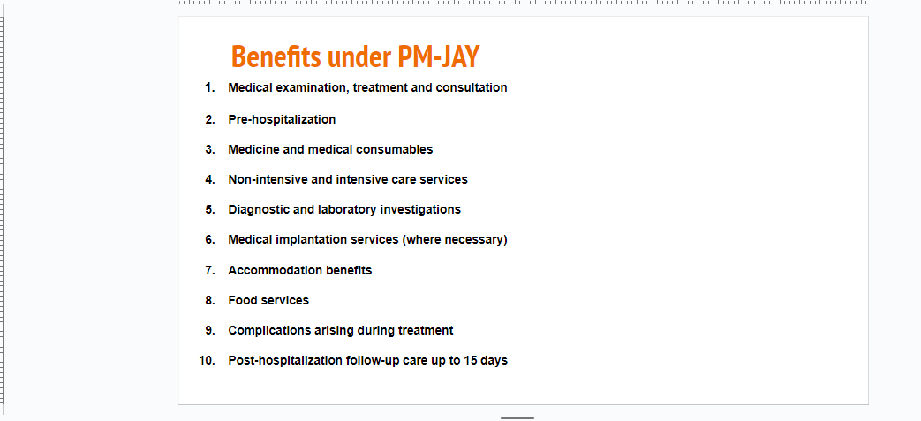
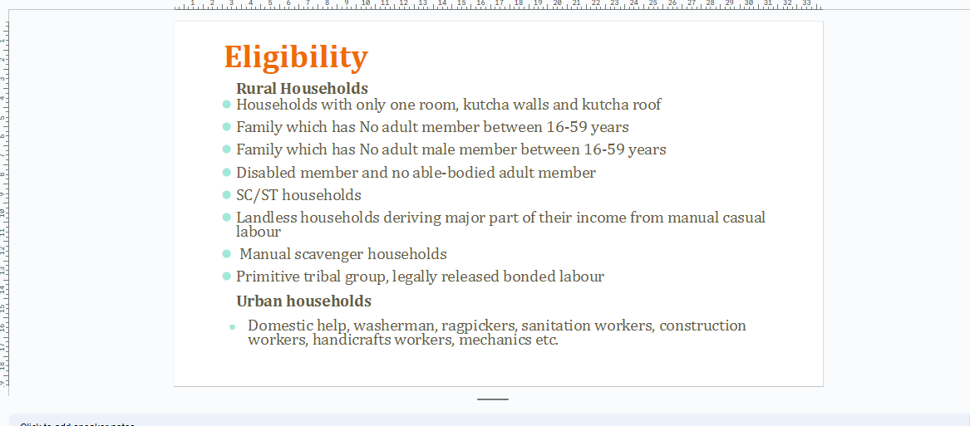
Life insurance:
Human insurance: Pradhan Mantri Jeevan Jyoti Bima Yojana
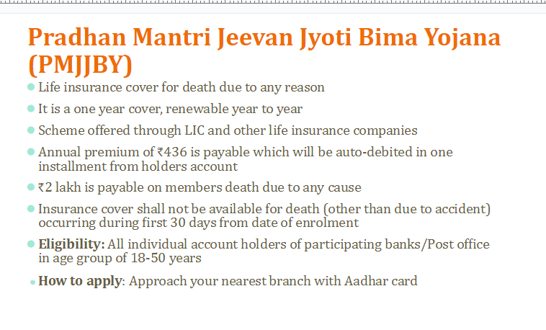
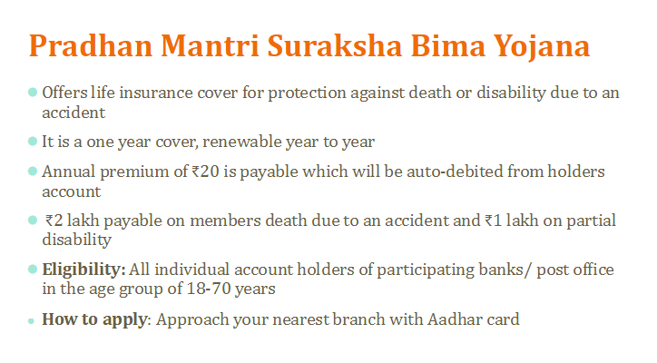
2. Livestock insurance
- animals per beneficiary per household for all animals except sheep, goat, pig and rabbit. In the case of sheep, goat, pig and rabbit the benefit of subsidy is restricted to a maximum of 50 animals.
- coverage of the scheme is the entire country since 21st May, 2014.
- 75% subsidy on premium for insurance of animals
Crop insurance- Pradhan mantri fasal bima yojana
- Provide insurance coverage and financial support to the farmers in the event of failure of any of the notified crops as a result of natural calamities, pests & diseases
- To stabilize the income of farmers to ensure their continuance in farming.
- To encourage farmers to adopt innovative and modern agricultural practices.
- To ensure the flow of credit to the agriculture sector
- How to apply: https://pmfby.gov.in/
Pension scheme:
Atal Pension
- Pension scheme focused on providing social security to unorganized sector workers
- Guaranteed minimum pension ranging between ₹1000 to ₹5000 per month depending upon the contribution of subscribers
- The exit is permitted at the age of 60. In case of death of subscriber, the pension will be available to spouse and on the death of both of them the pension corpus would be returned to nominee
- Eligibility: Subscriber should be between 18-40 years and should have a savings account in bank or post office
- Non -income tax payee
- How to apply: Approach your nearest bank branch
Indira Gandhi old age pension scheme
- Pension scheme focused on providing social security to unorganized sector workers
- Guaranteed minimum pension ranging between ₹1000 to ₹5000 per month depending upon the contribution of subscribers
- The exit is permitted at the age of 60. In case of death of subscriber, the pension will be available to spouse and on the death of both of them the pension corpus would be returned to nominee
- Eligibility: Subscriber should be between 18-40 years and should have a savings account in bank or post office
- Non-income tax payee
- How to apply: Approach your nearest bank branch
Indira Gandhi Widow Pension scheme
- GoI provides financial assistance of ₹200/month
- Eligibility: Widow in age group of 40-59 years from BPL household
- Whom to approach: Gram panchayat office
Indira Gandhi Disability Pension scheme
- GoI provides financial assistance of ₹300/month (between 60-79 years) and ₹500/month (80 years and above). State govts also contribute to this financial assistance.
- Eligibility: Applicant should be minimum 60 years old, belong to BPL and not receiving any other social welfare pensions
- Whom to approach: Gram panchayat office
- The facilitator will inform about these schemes and other such schemes sponsored by state government also. The facilitator will request participants to raise queries, if any.

Session 10: Group exercise on lakhpati planning tool
Duration: 3.20 hours
Day 2
Session 10
Group exercise on lakhpati tool
Objective: This session of the training is aimed at giving an understanding of filling of components of lakhpati planning tool:
Understanding location of SHG and its members
Detail of SHG household family members
Livelihood activity including institutional linkage and financing
Identifying livelihood activity undertaken by SHG members, calculating net income and planning for next year
Identifying support required for planned livelihood activities

Time – 3.20 Hours

Materials Required: PPT, projector & laptop, planning tool hard copy for groups, White board and marker
Methodology: Presentation and Discussions
Delivery:
Form 4-5 sub-groups of the participants
Distribute one copy of hard copy of planning tool to each group
Ask each group for the following:
i.One member of group should act as lakhpati CRP and other as SHG household members
ii. Brief the group about the format filling.
iii. Support the groups by clearing their doubts on the form related queries
iv. Set a time of one hour for each group to fill the planning tool.
v. One the time is over, ask each group to present their details with the other group members.
vi. Encourage other group members to raise questions on the different aspects of form filling.
vii. Give feedback to each group on the scope of improvement.
viii. In the end thank all the members for participation and remind them to recall the learning from the session when they are filling form.

on lakhpati
Duration: 30 Minutes
Day 2
Session 11
Orientation of VO/CLF on lakhpati
Objective: This session of the training is aimed at giving an Overview of VO concept seeding sessions through ppt and module:
Lakhpati concept
Significance of roles of CRPs
Filling Planning tool : Member’s profile and play on understanding importance of diversification in plan
Livelihood planning at SHG household
Process of livelihoods planning
Point of reference for CRP during plan preparation
Lakhpati planning tool
Role of VO in lakhpati didi
Aajeevika register
Time – 30 Minutes

Materials Required: PPT, projector & laptop
Methodology: Presentation and Discussions
Delivery:
The facilitator shall give an overview of orientation to CO/CLF on lakhpati, to the participants. They must be made aware that this orientation of VO is on planning livelihoods for lakhpati didis.
- Lakhpati concept
- Significance of roles of CRPs in lakhpati process
- Understanding livelihoods
- Strategy for livelihoods planning
- Process of livelihoods planning
- Point of reference for CRP during plan preparation
- Lakhpati planning tool
- Role of VO in lakhpati didi
- Aajeevika register
At the end of orientation of VO on lakhpati concept VO EC members are expected to have enhanced knowledge on
Who, what and how of lakhpati Didi?
What is livelihood, its types and need for household level planning, need of diversification, elements of livelihood planning- assets, skills and access and their relevance
- Role of VO and CRP
- Understanding livelihoods and its type
- Details of lakhpati didi planning tool
- Monitoring progress through aajeevika register
- SHG level planning meetings calendar
The facilitator shall share and explain the session plans of the orientation of VO/CLF Concept. The orientation VO/CLF will be the responsibility of the lakhpati CRP. e

L

akhpati household Livelihood planning
Day 2
Session 12
Lakhpati household Livelihood planning
Objective: This session of the training is aimed providing following information to SHG household:
Sharing Lakhpati concept with Didi with the reflection of themselves as role model for the community in livelihood.
Role of CRP in making of lakhpati didi
Support SHG household in planning their next year Livelihood planning

Time – 120 Minutes

Duration: Minutes for 1st session and 5 hours for 2nd session.
Materials Required: PPT, projector & laptop
Methodology: Presentation and Discussions
Delivery:
The objective of this part of module is to develop clarity to CRP about the content she has to deliver before SHG Didis to give them
- Clarity on the Lakhpati Didi with the realization that they are the role models for the rest of the Didis and should plan livelihood as models.
- They will be informed about the planning tool, the selection of the activity of livelihood either through diversification or deepening strengthening and expansion.
- The role of CRP in making of lakhpati Didi and how she will support them in the intervention.
- The record keeping of the planning livelihood activity for lakhpati initiative as per ajeevika register.
- Session plan- Day-1 :

Timing | Content | Link to presentation
Session 1: 9.30am to 10.30am | Registration of participants &Training overview | Ppt CRP to Lakhpati Didi:  ~$DIDI.pptx  Planning tool:  https://docs.google.com/spreadsheets/d/ 12sytH15UkZni43aQvD3J5waHubAG1w-4/edit?usp=sharing&ouid= 111221402645274011756&rtpof=true&sd=true  Play to learn diversification:  https://docs.google.com/document/d/ 16TMfYGKZ3vzyRXJJ9xiGKo0tzLmpbv7b/  edit?usp=sharing& ouid=107469613829008637202&rtpof=true&sd=true
Session 2: 10.30am to 11.15am | Understanding about Lakhpati Didi & their position as role models for other Didis
Tea break 11.15am to 11.30am
Session3:11.15 am -12.45pm | Discussion on planning tool & play for understanding importance of diversification in livelihood plan
Session 4: 12.30pm – 1.15pm | Role of CRPs in “Making of Lakhpati Didis”
Lunch break: 1.15pm-2.15pm
Session 5: 2.15pm-3.15pm | Self-assessment of progress through Aajeevika register | Aajeevika register:  https://docs.google.com/presentation /d/1J4vfGXRSpFoHAgDJdJgLTAR1ieEGwHNq /edit?usp=sharing&ouid= 111221402645274011756&rtpof=true&sd=true
Session 6: 3.15pm-4.00pm | Scheduling of submission date of filled up Livelihood part of planning tool after discussion with family members by Lakhpati Didis to CRPs  Outline of orientation on selected livelihood plan by domain experts

The facilitator will welcome the Lakhpati SHG Didi for orientation on planning on next year livelihood in such a way that they have income of Rs. one lakh or more. The livelihood selection process and implementation on lakhpati plan will be a model for rest of Didis and hence Lakhpati Didi should be motivated to visualize themselves as role model and ensure effective implementation.
The strategy for lakhpati making involves filling up planning tool which has three segments- member profile, livelihood planning segment and support system as ‘ASA”.
Didi’s will fill up the member profile and based on the learning from the orientation of CRP they will discuss the livelihood options with the family members and submit the same to CRP at the designated time.
After collation of livelihood activities of all the lakhpati didis the experts of identified activities will provide one day orientation to the concerned Didis.
Session plan: Day 2- Orientation by domain experts
After livelihood planning tool data collation of each household the experts identified on each domain area will take one day orientation session on value chain, inputs required, possible support through convergence, risks involved, availability of the market, technical & economic viability of the business etc.
After the expert orientation, the Lakhpati Didi will fill the third and final section of the planning tool and submit the same to CRP.

Duration: 15 Minutes
Day 2
Session 13:
Valedictory & feedback
Objective:
Filling of feedback form by the participants either online or in the hard copy.
Thanking all the participants for their contribution to the training programme.
Time – 15 Minutes
Materials Required: Hard copy of feed-back and pen/Laptop/mobile, projector.
Methodology: Discussion by facilitator
Delivery:
The facilitator will ask if any participants are having any doubts before closing this session.
The facilitator will thank the participants for active participation in the training programme.
Hope the participation will be fruitful for them and the lesson learnt will be useful in work.
Then an online link of the feedback session will be shared with the participants for filling up the feedback form.
https://docs.google.com/document/d/16TMfYGKZ3vzyRXJJ9xiGKo0tzLmpbv7b/edit?usp=sharing&ouid=107469613829008637202&rtpof=true&sd=true
In case there is an issue of data availability then the hard copy of feedback form will be filled by the participants.
https://docs.google.com/document/d/1J4VqqTQdoZOpG80xVZ5k5gA6SSAia8Ml/edit?usp=drive_link&ouid=111221402645274011756&rtpof=true&sd=true
A guideline on filling the format will be shared by the facilitator with the participants. The participants should be informed that the name of the person giving feedback will not be disclosed so they should not fear while filling up the feed-back form.

